

Operator's Manual

Programming Coin Mechanisms

Mektek 3
Software Version
Classic 3.0.4 or later
Plus 3.11 or later

Contents

Mektek 3 Manual 3.7
Mektek UK Ltd
“Agates” Halldore Hill
Cookham
Berks
SL6 9EX
U.K.

Tel: (44) 1628 525525
Email: sales@mektekinternational.com
Website: mektekinternational.com

Installation
PC requirements, software installation, connection, Programmer to PC connection, configuring your system.
Mechanisms supported

How the programmer works
Validator function, programmer function.

Credits
What is a credit, checking & loading credits.

Classic program:

Data storage devices
Purpose, Coin Controls/NRI EEPROM, Mars PROM & E+1

Getting started
Looms, Coinset Files, coins.

Basic reprogramming routines
Mars – example MS1600 (Using a Coinset File) - V3.0.4 & later software
Coin Controls – example C120 (Using a Coinset File) ) - V3.0.4 & later software
All types - Wizards - Add/replace a coin, Slug Fix, Edit Limits.

Discriminating against a known slug
Using Coinset file and Slug Fix Wizard

Additional features:
Mars - PROM Utilities, Flier limits.
Coin Controls/NRI - EEPROM Utilities, Cloning.

Reprogramming by mechanism type
Mars: MS1000, MS1400, ME111/MS111, ME181, MS130B1
Coin Controls: C120, C220B, C335, C435/C435A, C450, C220/Sentinel
NRI: G13, G10, G40
Help
Obtaining Coinset Files, Updating operating software, technical help.
Fault finding table
Mechanism fails validator test after programming – identify the problem, tuning Limits.

Description of Screens:
Capture Measurements & PROM Limits

Description of generic Coinset Files

Plus Program:

Getting started

Basic reprogramming routine (CF115, 126, 330 & 560)

Settings (560)

Settings (CF115,126, 330)
Enable channel, Window width, Output line, BCO Hex Code, BCO inhibit line, Routing header, Memory routing.

Reprogramming CF330
Settings, Programming & Discriminator selection.

Reprogramming & settings (CF340 Creditor)
Interface board ( RVCI function, Single/Multi Player, Bonuses), Reprogramming, Test Function, Settings.
Utilities
Save to File, Load from File, Copy Configuration,

Validator LED code

Restoring Original Configuration from Backup File

Help
Updating operating software, technical help,
Fault finding table
Connecting Loom Selection

.

24v input
Indicator LEDs
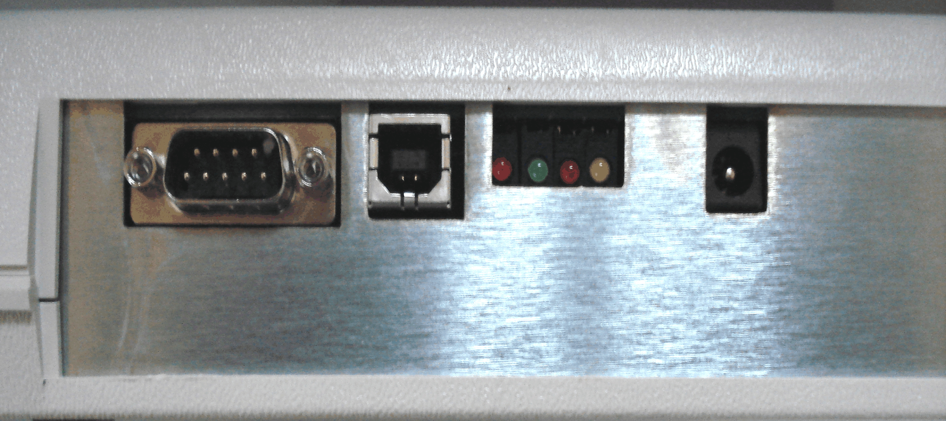
USB port
Serial port
PROM socket
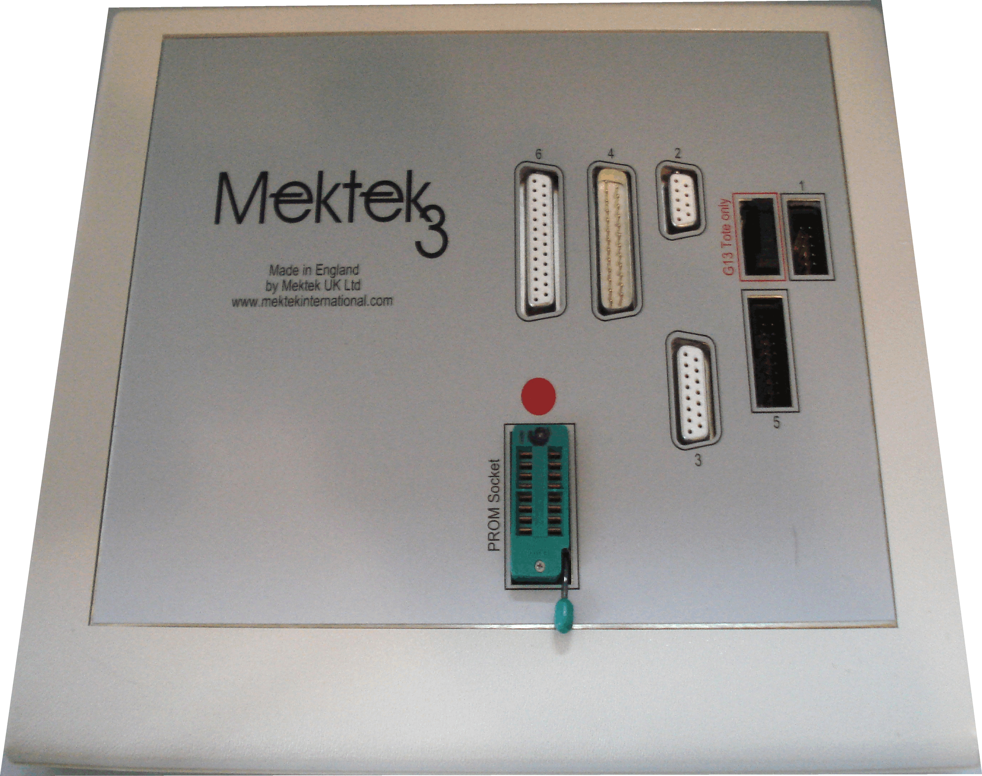

Installation – Classic and Plus modules

Recommended PC requirements
IBM PC or compatible, Pentium 100MHz or faster
16 Mb RAM (32 Mb recommended)
20 Mb free hard disc space
Windows 95/98, ME, XP, 7 or 8.1 (Mektek do not currently recommend the use of Windows 10 or Vista)
One free RS232 serial port with 9-pin connector or one free USB port
Standard Keyboard and Mouse
CD Rom drive
Internet & Email links are recommended for credit requests & software downloads.
Warning: Do not connect the power supply to the programmer until a USB or Serial lead is connected.

Software installation, connections and configuration – Windows XP, 7 & 8.1

Software installation
- Insert the Installation CD. The CD should start automatically. Select file name Setup.exe and click on OK. Follow the on-screen instructions.
Note: When using Windows7(64bit) an error message may appear regarding installation of a driver. Click on OK. Go to folder C:\Program Files(x86)\Mektek and double/click on file CDM20802_Setup to run it. Installation is then complete. For Windows 8.1 the process is similar but browse the Installation CD to run file "CDM v2.10.00 WHQL Certified"

Connecting the programmer to the PC (USB)
- Connect the Programmer to a USB port on your PC using the supplied cable.
- Power up the unit using the supplied 24volt PSU.
- The New Hardware Found and Working OK should appear.
- Go to Control Panel, (System, Hardware), Device Manager, Ports and note the “COM” number against the USB Serial Port entry.

Connecting the programmer to the PC (Serial port)
- Connect the Programmer to a serial port on your PC using the supplied cable. Power up the unit using the supplied 24volt PSU.
- Go to Control Panel, System, Hardware, Device Manager, Ports and note the “COM” number against the Communications Port entry.

Configuration
- Start the Programmer Module by clicking on the Mektek Plus desktop Icon. When the Main Menu appears select COM Port number found in the previous section. Exit the program to store the configuration.
- Click on the Mektek Classic icon. When the Main Menu appears select COM Port number found in the previous section. Select the Language required as well and Click on Save Config and Exit. To modify settings select Change Configuration in the main menu which will appear when the Programmer software is restarted.
Note: The Configuration must be set for each Module used.
Note: If the wrong Port is selected a dialogue box will appear when the Program is restarted. Select the correct Port and continue.

Software installation (Windows 95/98 & ME)
- Insert the Installation CD. The CD should start automatically. An error message will appear saying that the Windows version is not suitable. Exit the message. Click on Run and type in the drive for the CD.
- Browse to find & select the folder Windows_98_ME. In this folder you will find 3 further folders – Mektek Classic, Mektek Plus and USB Drivers. Open each folder in turn and run the Setup.exe file in each.

Connecting the programmer to the PC (Serial port)
- Connect the Programmer to a serial port on your PC using the supplied cable. Power up the unit using the supplied 24volt PSU.
- Go to Control Panel, System, Hardware, Device Manager, Ports and note the “COM” number against the Communications Port entry.

Connecting the programmer to the PC (USB)
- Connect the Programmer to a USB port on your PC using the supplied cable.
- Power up the unit using the supplied 24volt PSU.
- The New Hardware Found and Working OK should appear.
- Go to Control Panel, System, Hardware, Device Manager, Ports and note the “COM” number against the USB Serial Port entry.

Configuration
- Start the Programmer Module by clicking on the Mektek Plus desktop Icon. When the Main Menu appears select COM Port number found in the previous section. Exit the program to store the configuration.
- Click on the Mektek Classic icon. When the Main Menu appears select COM Port number found in the previous section. Select the Language required as well and Click on Save Config and Exit. To modify settings select Change Configuration in the main menu which will appear when the Programmer software is restarted.
Note: The Configuration must be set for each Module used.

Note: If the wrong Port is selected a dialogue box will appear when the Program is restarted. Select the correct Port and continue.

Mechanisms Supported (V3.0.2 software on) Looms in GREEN are included in the standard loom sets.

Classic Program
Mars Mechanisms
Mechanism | Coinset file family | Loom(s) | Comments
ME111, ME115, ME115TS, ME126, ME129, MS111B1 | ME111 | E2 | 20 pin connector
MS111, MS125, MS126, MS127 | ME111 | E8 | 16 pin connector. Remove separator
MS110 | ME111 | E17 & E32 | Edge connector
MS1600, MS1900, ME1099 | MS1000 | E1
MS1400 | MS1400 | E7 | Klix machine
MS130B1, MS180 | ME111 | E5 & E6
ME181, ME112 | On request | E3 & E4 & E31 | Connect E31 to E3 if no flying ribbon cable on mechanism
MS150 | On request | E9
MS15, MS16(Plug-in PROM only), MS25 | ME111 | E30
MS140, MS160 |  | Special looms required | Contact Mektek
MS10, MS13 | ME111 | E34
MS12 | ME111 | E33

Coin Controls Mechanisms
Mechanism | Coinset file family | Loom(s) | Comments
C120 | C120 new type  C120 “Jaguar” | E10 & E11 | See rear of PCB for identity.  Binary operation not supported
C220/C220A, Sentinel | * Sentinel | E17 & E25 | Binary operation not supported
C220B | C220B | E12 & E17 | Binary operation not supported
C335/C335S | C335 | E12 & E16
C435, C435A, C420 | C435, C435A. Ensure correct binary coding option selected | E11 & E13
C450, C455 | C450 | E20 & E23

NRI Mechanisms
Mechanism | Coinset family | Loom(s) | Comments
G13-0000, G13-1000 (Not Mft) | G13-0000 | E10 & E14 | 1x6 way DiL switch only
G13-6000, G13-7000 (Not Mft) | G13-6000 | E10 & E14 | 1x6 way DiL & 1x6 or 1x8 way DiL switches
G13-0000, G13-1000 Tote (Not Mft) | On request | E10 & E14 | As above for acceptor
G13-6000, G13-7000 Tote (Not Mft) | On request | E10 & E14 | As above for acceptor
G10-4000, G10-4000/2 | On request | E15 | Ask for individual variants supported
G10-4000/5, G10-4000/6  G10-4000/9 | On request | E15 | Ask for individual variants supported
G26 (G10-4000 validator) | On request | E15
G26 (G10-4000/5 validator) | On request | E15
G18-0000 | On request | E20 & E21 & E22 & E24 | G18-0000 Interface Adaptor and user-supplied 24v PSU required
G18-3000 | G18-3000 | E14 & E20
G40-x3xx, G40-x4xx | G40 | E13 & E26
G40-x0xx, G40-x5xx, G40-x6xx | G40 | E14 & E20

Plus Program
MEI Cashflow
Mechanism | Loom(s) | Comments
CF115/126 | X3 - connect both branches | CF115 is a Cf126 without separator
CF330 | X3 – both branches  E10 + X3(6 way square only)  E20 + X3(6 way square only) | Depending on Interface fitted – see “Connecting loom selection”  at the end of the Plus section for detailed instructions.
CF340 | X4 - connect both branches
CF560 | X3 or X4 – connect 6way square connector only. | Requires Route Alpha to set values & routing

How the programmer works
Validator function
In principle, validators measure the outputs from in-built sensors as a coin passes them. The values are then compared with a table of preset values held in memory. If the outputs are all within the limits specified for one of the programmed coins in the table the coin is accepted and a signal sent to the host machine/changegiver that a coin type A, B, 1, 2, etc has been accepted. Values are usually assigned to each coin outside the validator, although some such as a Totaliser do require the values to be set.

Programmer function
20 coins of each type to be programmed are dropped through the validator. The Mektek Programmer takes the outputs from the sensors as coins are dropped through, performs a statistical analysis on the values and generates limits appropriate to the validator and to the coins to be programmed. The data is then transferred to a plug-in memory device which is inserted into a socket on the validator for older Mars units or directly into the EEPROM for Coin Controls, NRI& Cashflow. Coins are passed through the validator to confirm acceptance.

Credits

What is a credit?
Each time the programmer is used for a chargeable operation a credit is deducted from the total held in the Programmer in a similar manner to a pre-pay mobile telephone. A warning message is displayed when the credits need replenishing. Credits can be purchased via Email from the supplier of your Programmer or Mektek.

Credit Usage
The routine of programming multiple coin channels, testing coin acceptance and changing settings if performed in one operation using a Coinset File on one coin mechanism consumes 1 Credit. If the mechanism is not disconnected from the Programmer the routine can usually be repeated without additional Credits being consumed
Use of a Wizard consumes 1 Credit.

Checking credits
To check the number of credits remaining in the Programmer or to order more credits start either program & click on Load Credits. The number of credits available is shown along with the number used.

Loading credits
- To replenish credits start the Programmer and click on Load Credits.
- Click on the Number Requested box and enter the amount required
- Click on Request More Credits and a unique code message of up to 40 characters will appear in the Code String box. Copy (double click on the box to select the field, right click on the mouse and click on Copy) then paste this number into an Email or Fax and send to your supplier.
- Once payment has been received a similar Code String will be returned.
NOTE:

Do not request further credits if an outstanding credit request exists.

If a Fault Message such as "Not a Valid Credit Issue Message" appears contact your Supplier.
- Paste the new code message into the box and click on Load New Credits.
- The Number Loaded will be displayed and added to those available.
- Click on Return to Main Menu to exit.
Classic Program

Data storage devices

Purpose
The limits generated for each of the coins to be accepted and occasionally values, inhibits and outputs are stored in a memory device .

Coin Controls, NRI, and MEI© EEPROM:
The data is stored in an integral EEPROM which can be reprogrammed.

Mars PROM & Mektek E+1:
For older Mars units the data is stored in a separate memory device plugged into the validator. The original – and now obsolete – PROM used in the Mars units is a one-shot device which cannot be reused. The Mektek E+1 device used in place of the PROM can be reprogrammed as many times as required, doing away with the need to replace the expensive PROM each time a validator is reprogrammed.
Segments:
In a PROM or E+1 device the storage is divided into segments, each of which can hold the limits for 6 coins. The segment to be used can be switched from one to the other but only one segment can be active at a time. In the case of a PROM switching is done by links or switches on the validator or by withdrawing the device and removing one of it’s pins. On an E+1 device Switch 1 selects the segments.

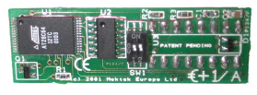
ON
1 2
Switch setting
E+1V - suitable for both 1k & 2k vending applications. Coloured Blue. (Red for MS1400 only)

E+1A - suitable for both 1k & 2k amusement & gaming applications. Coloured green.

Getting Started

- Read the "Quick Guide to Programming" supplied with your Programmer for an overview.
- For further information check the information on specific coin mechanisms elsewhere in this Manual.
- Check in the Mechanisms Supported page that you have the required loom(s) for the mech type to be programmed. If a Special Order loom is necessary, contact your supplier.
- Classic Program: For a single programming operation a Wizard can be used instead. For mulitple operations a suitable Coinset file is used.
- A Coinset File – which instructs the Programmer unit on mech type, coin channels, quantity of coins to be dropped, limit calculations, segments used etc. – is needed. The Coinset File must be suitable for the mech type and coin configuration that you are planning to program. See the Appendix for a list of generic Coinset Files included in the installation. If a suitable file is not included contact Mektek. New Coinset Files for specific applications are supplied free-of-charge.
- Obtain 20 coins of each denomination to be programmed.
- Obtain supplies of PROMs or E+1 devices for old type MEI mechanisms.

Reprogramming routine MARS using Coinset Files
- Clean and dry the path of the coins through the validator using a soft cloth and a non-solvent cleaner.
- Connect validator to programmer using appropriate loom(s)See “Reprogramming by coin mech type” and Appendix for details.
- Mount the validator in the correct alignment
- Start Programming System from the Desktop Icon – Mektek Classic.
- Select Mars and the type required from the Drop down box and click on Validator test.
- Drop current coins through the mech and check acceptance to confirm that the validator is working
- Click on Back to Main Menu
- Click on Program Mech
- Click on Duplicate Segments (This will put the same data into both segments so that the mechanism will work regardless of which segment it has been set for.) Do not use if different segment data is required.
- To add a single coin go to the Wizards section on Page 14, otherwise Click on Run Coinset File
- Open the appropriate coinset file (See Appendix for description of generic files or use a Custom file available from Mektek)
- Once the Coinset File has been opened a box will appear for the first Coin Type coin with three options. (The Coin Type may be generic such as A1 or specific such as 5c.)
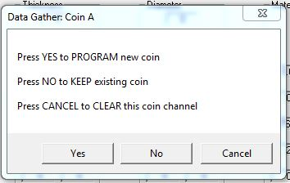
Prom size: The size of PROM or E+1 to be programmed - 1k or 2k
- Click on YES to start the coin drop if you want to program this channel or Click on NO to keep this coin and step on to the next one or Click on CANCEL to clear the Channel and step on to the next one.
- If you clicked YES drop 20 coins through the validator and then OK..
- Repeat the process for the rest of the channels until “Data Gathering Complete appears.

*Segment 2 is displayed. To read the rest of the data, click on the segment in Display PROM Segments.

- The estimated acceptance of each coin is displayed. If required adjust the limits by overtyping then click on Change Limits to see the revised Acceptance. Adjust if necessary. Clicking on Restore Limits will restore the limits to their original values.
- Select the type of device to programme in Target Prom type
- Click on Program New PROM
- The Deducting Credits message appears.
- Click on OK to proceed.
- Insert a PROM in the socket of the Programmer. (Notch in PROM towards the Red Spot)
- Click on OK to programme the device.
- The Verify PROM OK message confirms that the PROM has been correctly programmed.
- Remove the PROM from the programmer and insert it into the socket on the validator. Ensure that the legs are correctly seated in the socket and the orientation is correct.
- Click on Validator Test
- Drop each type of old coin through the validator and confirm that the appropriate lamp lights. If slugs are suspected drop these and confirm that they are rejected.
- If one or more coin limits need to be widened to improve acceptance or narrowed to reject a slug, click on Back to Main Menu to return to the Prom Limits screen. Adjust limits as required and program a new PROM as before then retest. Further adjustments and retests can be carried out on the mechanism without consuming another credit provided you do not disconnect the mechanism.
- Click repeatedly to return to the Main Menu ready for the next validator.
- Remove the validator from the stand, disconnect loom, and affix a suitable label to the front giving details of the new coins accepted.

Reprogramming routine Coin Controls & NRI using Coinset Files
(The description is for Coin Controls but applies equally to NRI mechanisms)
Note:
- Clean and dry the path of the coins through the validator using a soft cloth and a non-solvent cleaner.
- Connect validator to programmer using appropriate loom(s)See “Reprogramming by coin mech type” and Appendix for details.
- Mount the validator in the correct alignment
- Start Coin Programming System from Start, Programs, Mektek.
- Select Coin Controls and the type required from the Drop down box and click on Validator test.
- Drop current coins through the mech and check acceptance to confirm that the validator is working
- Click on Back to Main Menu
- To add a single coin go to the Wizards section on Page 14, otherwise Click on Run Coinset File
- Open the appropriate coinset file (See Appendix for description of generic files or use a Custom file available from Mektek)
- Once the Coinset File has been opened a box will appear for the first Coin Type coin with three options. (The Coin Type may be generic such as A1 or specific such as 5c.)
Prom size: The size of PROM or E+1 to be programmed - 1k or 2k
- Click on YES to start the coin drop if you want to program this channel or Click on NO to keep this coin and step on to the next one or Click on CANCEL to clear the Channel and step on to the next one.
- If you clicked YES drop 20 coins through the validator and then OK..
- Repeat the process for the rest of the channels until “Data Gathering Complete" appears.
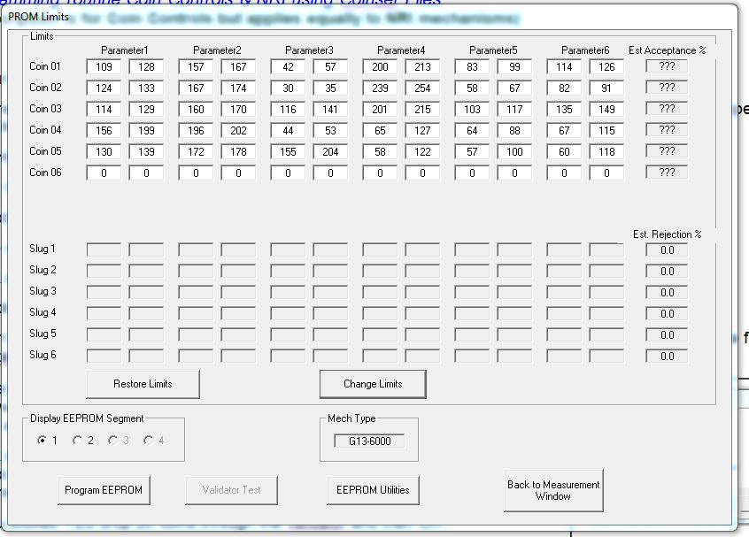

- The estimated acceptance of each coin is displayed. If required adjust the limits by overtyping then click on Change Limits to see the revised Acceptance. Adjust if necessary. Clicking on Restore Limits will restore the limits to their original values.
- Click on Program EEPROM
Prom size: The size of PROM or E+1 to be programmed - 1k or 2k
- The Deducting Credits message appears.
- Click on OK to continue.
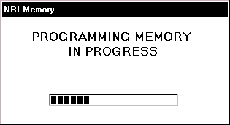
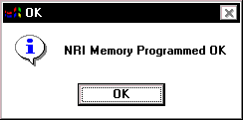
- The memory will be programmed
- Click on OK to complete.

- 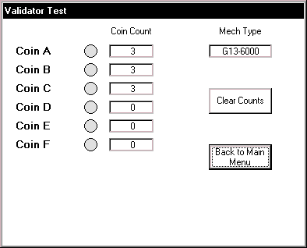Click on Validator Test
- Drop each type of coin through the validator and confirm that the appropriate lamp lights. If slugs are suspected drop these and confirm that they are rejected.
- If one or more coin limits need to be widened to improve acceptance or narrowed to reject a slug, click on Back to Main Menu to return to the Prom Limits screen. Adjust limits as required by overtyping and clicking on Change Limits, reprogram the EEPROM as before then retest. Further adjustments and retests can be carried out on the mechanism without consuming another credit provided you do not go back to the Measurement Window.
- Click on Back to Main Menu, Back to Measurement Window and Back to Main Menu ready for the next mechanism.
- Remove the mechanism from the stand, disconnect loom, and affix a suitable label to the front giving details of the new coins accepted.

Wizards

Wizards are special routines to carry out specific tasks without going through a complete programming sequence. They do not require the use of a Coinset File. Each use of a Wizard consumes a credit.
(The description below is for MARS but a similar routine applies for NRI & Coin Controls mechanisms)
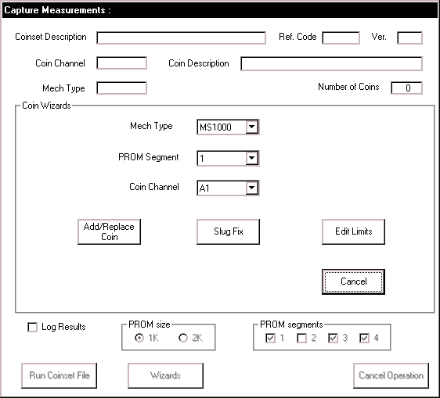
- Access the Wizards from the Main Menu
- Select make of mech to be used eg. Mars
- Click on Program Mech
- Click on Wizards

Add/Replace Coin
Used to gather data on a new coin and add it into a spare coin channel on an existing coinset held in a PROM/ E+1. Instead of adding it into a spare channel, it can also replace an existing coin.
- Select Mech Type
- Select the PROM segment and Coin Channel to position the new coin.
- Click on Add/Replace Coin
- Click on OK and drop 20 coins
- Click on OK and the follow the screen prompts to read the old PROM.
- The PROM limits screen will appear with the limits from the old PROM and those generated by the coins dropped. Adjust as required and then Program New PROM and Validator Test as per the Basic Programming Routine.

Slug Fix
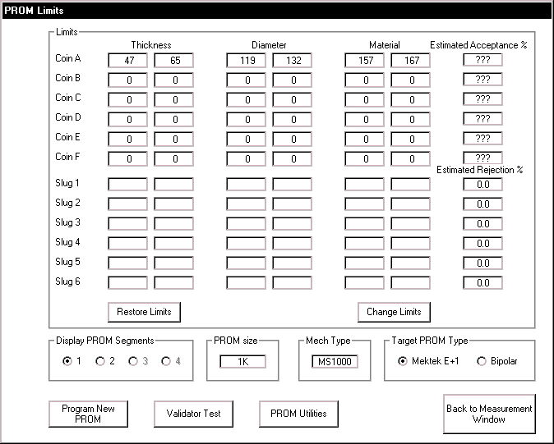A Slug is an item which a validator incorrectly assumes is a particular genuine coin. eg machined blanks, foreign coins, two coins glued together. The validator can usually be recalibrated to discriminate between the real coin and slug by running the slug through the Programmer and adjusting the existing limits for the coin to exclude the slug. Slug Fix can be used at any time to carry out this task.
- The routine for this is the same as per Add/Replace a Coin above except that in addition the programme asks for a Slug Drop. ie drop 15 of the slug through the validator as if it were a coin. Adjust the limits as required to remove the yellow overlap between coin and slug and confirm rejection of the slug using validator test.

Edit Limits
This routine reads the data from an existing PROM or E+1 and displays it on the PROM limits screen. The limits can be manually adjusted. (For example: Opening up to improve acceptance or shutting to zero to remove a coin). The routine for this is the same as per Add/Replace a Coin above except that no coin drop is required.

Discriminating against a known slug
If a known slug exists it can be removed while programming for new coins using a suitable Coinset file or at a later date using the Slug Fix wizard.

Using a Coinset file:
- Some of the generic Coinset Files included with this unit include the option of dropping one known slug as part of the programming process.
- When requested drop through the quantity shown of the slug to be removed.
- At the Limits screen the slug and the coin affected will be highlighted in yellow.
- Adjust one or more of the Limits of the coin to remove the overlap and click on Change Limits. The estimated acceptance of the coin and reject %age of the slug will be displayed. If suitable proceed with programming, if not retry using a different adjustment.

Notes: In a few cases, due to the nature of the mechanism and slug, it may prove difficult to completely remove the slug while still retaining adequate coin acceptance. In this case contact Mektek for advice.

Using a Slug Fix Wizard:
See the Slug Fix option in the Wizards section.

Additional Features

Mars

PROM utilities
From the Main Menu or the Prom Limits screen the option of PROM Utilities can be selected.
- Click on PROM Utilities

- 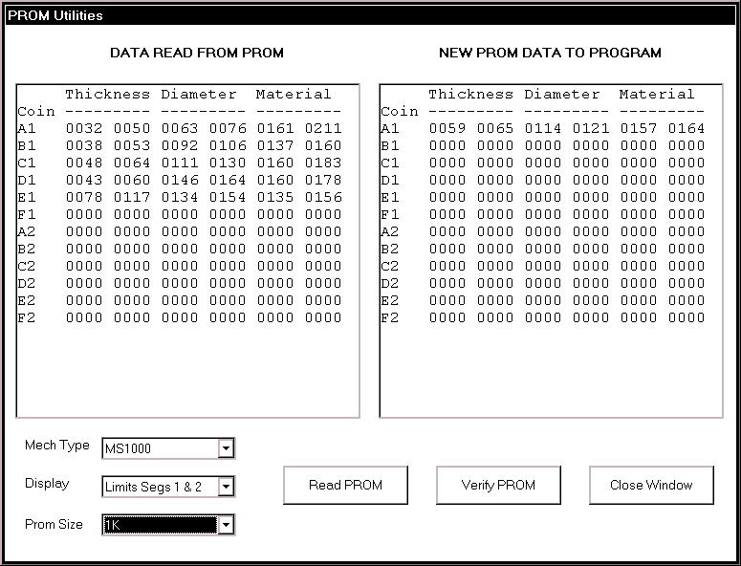Insert the PROM or E+1 into the socket on the Programmer.
NOTE:
If entering from the PROM Limits screen, this box will contain the limits/data for the validator being programmed.

- Click on Read PROM
- The contents of the PROM will be displayed in the left box.
- Select Limits or Data from the Display box.
- In the Limits display the upper and lower limit for each parameter of each coin are shown.
- In the Data display the data is displayed in HEX format.
- Click on Close Window to return to previous screen.

Flier limits
Occasionally, out-of-range readings are generated by the a sensor as a coin passes. This can be due to the coin bouncing or following another coin too closely etc and is termed a “Flier”. It may also result from incorrect orientation of the coin mechanism which will result in poor acceptance. If Fliers occur during programming an error message is shown and further coin drops may be requested to complete the Data Gather. Click on OK and drop the coins if required.

Coin Controls/NRI

EEPROM/Memory Utilities
- From the Main Menu select the make of mechanism
- Click on EEPROM Utilities (Coin Controls) or Memory Utilities (NRI)
- The Limits contained in the Memory are displayed.
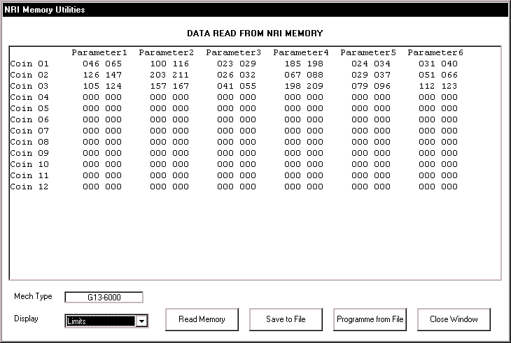

Display of other information (eg parameters, mapping, etc):
Depending on which type of mech is being used other information may be available. See individual mechanism section for details.

Save to File:
Click on Save to File to save the EEPROM/Memory data to a file. Used as part of the Cloning Routine and to save the data from a mechanism in case it needs to be returned to it’s original settings.

Program from File:
Click on Program from File to program the EEPROM from a previously saved file. Used as part of the Cloning Routine and to return a mechanism to it’s original data if stored.

Cloning:
Cloning of additional parameter settings:
When converting to different coinage, additional parameters in some mechanisms (G13, G18, G10, C120, C220B, C335, C435, C450) may require changing. For instance: Output Mapping (Which channel outputs where), Binary Coding and Output paths.
The facility to change these as part of the Programming is included in some Coinset files but not all. Also the setting may have been changed inadvertently by selecting the wrong Coinset file when programming. Cloning allows the user take the additional parameter data from a sample mechanism that already has the required settings and put it into the mechanism being programmed. Important: All required coins must be programmed after Cloning as the existing coin data is overwritten by the Cloning. With the latest software version this does not use a Credit.
Cloning Routine:
1. Connect sample mechanism of same type to be programmed with known correct additional parameter settings. Using Memory Utilities, Save EEPROM to File.
2. Connect mech to be programmed. From the Main Menu click on Program Mech. Then tick the box Clone and select Run Coinset File.
3. Select the File from Step 1 above & Open. Confirm Overwrite EEPROM.
4. When Open Coinset screen appears select the required Coinset File and program in the normal way. This will use one Credit..
Note: All coin mechanisms must be individually reprogrammed for coins as part of the Cloning Routine.

Reprogramming – by coin mech type

Mars

MS1000 family: See Appendix for listing of individual mechs supported.
Programme as basic MARS routine but note the following:
- Connect loom E1 MS1000 (Ribbon) from Socket 4 of programmer to bottom of validator.
E+1 usage:
- Use E+1V (Blue) fitted as shown.

- MS1900 has two PROMs – fit E+1 to lower one. Remove upper PROM when switching to Segment 2 coin set to stop acceptance of old coins G, H & I.
- If more than 6 coins are required in one coinset program coins A to F into Segment 1 of the E+1V and Coins G to I into Segment 2 of a PROM. Insert the E+1V into the lower socket and the PROM into the upper socket.
Validator Test:
- If “Duplicate Segments” was not selected during programming & all coins are rejected on Validator Test the validator may have been modified to use Segment 2. Use the Edit Limits Wizard (with Segments 1 and 2 selected) to reprogram the device with the same data in both segments and retry.
Fitting to Changegiver:
- Consult the manufacturer’s documentation for details of mapping coins to change tubes etc.

MS1400 Klix
This mechanism is fully supported including the E+1K. Consult Mektek for detailed information.

ME111 family: See Appendix for listing of individual mechs supported.
Programme as basic MARS routine but note the following:
- Connect loom E2 from Socket 4 of Programmer to 20 -way connector

E+1 usage:
- Most of these mechs will have a number of sets of pins above the PROM socket. Before fitting E+1A (Green) clip off the tops of these pins to the level of the links to allow E+1 to seat onto PROM socket.

Validator test:
- If “Duplicate Segments” was not selected during programming & all coins are rejected on Validator Test the validator may have been modified to use Segment 2. Use the Edit Limits Wizard (with Segments 1 and 2 selected) to reprogram the device with the same data in both segments and retry.
Selecting segments:
- E+1 – use SW1 to switch from Segment 1 to Segment 2.
- PROM – withdraw Leg 15 to switch to Segment 2.

MS111 family: See Appendix for listing of individual mechs supported.
Programme as basic MARS routine and ME111 above but note the following:
- Coinset files as per ME111
- Connect loom E8 from Socket 4 on Programmer to 16 -way connector
E+1 usage:
- On some MS100 variants there may be insufficient clearance for an E+1A to be fitted. In this case use a bipolar PROM.

ME181/ME112
- Programme as per basic Mars routine but see below.
- Obtain a Coinset File with the required Coin Values from Mektek.
Looms required:
ME181:
E4 : ME181 2/2 (Wire) - socket 4 to side of mechanism
E3 : ME181 1/2 (Ribbon) – socket 3 to flying lead from mechanism
ME112:
E4 : ME181 2/2 (Wire) - socket 4 to side of mechanism
E3 : ME181 1/2 (Ribbon) – socket 3 to end of E31
E31: ME112 2/3 (Ribbon) – between the end of E3 & bottom of mechanism
E+1 usage
- Use only E+1A (Green) or 2k PROM. Two segments are programmed with the coinsets and the other two segments have the values for the coins in these segments. Follow the on-screen prompts when programming.
Selecting segments
- Set switch 1 (SW1) on the validator to OFF to select Segment 1 and ON to select Segment 2.

Coin Controls

C120 family: See Appendix for listing of individual mechs supported.
Programme as basic Coin Controls routine but note the following:
- Binary operation is not supported.
- CAUTION: Different Programmer connections are used for Acceptors and Totalisers. Connecting the E10 Ribbon Cable from an Acceptor to the G13 Tote Only socket on the Programmer can damage the Programmer and/or mechanism.
- Looms required:
E10 G13/C120 from socket 1 to rear of validator as shown
E11 C120/C435 from socket 2 to rear of validator as shown.
- Any overlapping limits or limit greater than 254 will cause coins to be rejected.

Old & new type mechanism identification:
Remove the rear cover. Old type C120s usually have the word “Jaguar” in the top right hand corner of the PCB.
Output Mapping:
- The ouput mapping – which Channel is output on which pin – can be changed by use of a suitable Coinset File. As the mapping data is stored differently in the old and new types it is important that the Coinset File chosen relates to the correct type if the mapping is to be changed.
- If no coins are accepted on Validator Test after programming or when fitted to the host machine it is likely that an unsuitable Coinset File has been used.

Display of other information:
- Read EEPROM and from Display select Other Information
The mapping is displayed. The settings are defined in the Coinset File and cannot be altered during programming.

Bank selection:
- Up to 12 coins can be accepted. They are split into two Banks - coins 1 to 6 in Bank 1 and 7 to 12 in Bank 2.
- Select Bank 1, Bank 2 or both Banks using the 4-way switch on the rear of the coin mech.
- Switch 1 to Off and Switch 2 to On to select Bank 1. Reverse for Bank 2.
For both Banks put both Switch 1 & 2 to Off.

Coin Inhibit:
- Individual coins in the active Bank(s) can be inhibited using the 6-way switch on the rear of the coin mech.
- Switch 1 to ON to inhibit Coin Channel 1 & 7, switch 2 to ON to inhibit Coin Channel 2 & 8 etc.

C220B:
Programme as basic Coin Controls routine but note the following:
- Binary Operation is not supported
- Looms required;
E12 C220B/335 from socket 2 to validator
E17 C220B from socket 3 to validator

Coin Accept Mode:
- In normal mode coins 1 to 4 are output on pins 1 to 4 and coins 5 to 8 (If enabled) are also output on pins 1 to 4. To use the 8-coin mode the host machine must tie the SELECT line (Pin 6) on the interface connector to 0V (Pin 10). In the 8-coin mode all 8 coins are accepted.

Coin Inhibits:
- Coins are inhibited by the host machine via the interface connector rather than via switches on the mechanism.

Acceptance faults when fitted to host machines:
- If coins are not being accepted on some host machines ensure that the Programmer software used is V1.2C or later.
- If problems still occur, use the Cloning Routine described in a previous chapter.
- Any overlapping limits or limit greater than 254 will cause coins to be rejected.

C335:
Programme as basic Coin Controls routine but note the following:
- Looms required;
E12 C220B/335 from socket 2 to validator
E16 C335 from socket 3 to validator
Coin Accept Mode:
- In parallel mode there are 5 outputs for up to 8 coins with coins 6,7 & 8 paired with coins 1,2 & 3 respectively. In binary mode up to 8 coins can be accepted.
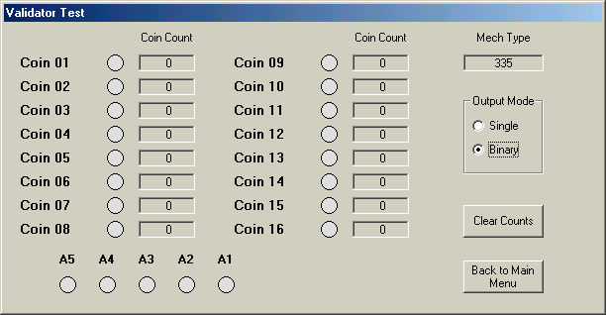
Validator test:
- Select Output Mode of either Single or Binary.
- In binary display as well as the coins accepted in binary mode the credit code in single output is shown by lights A1 to A5.

Coin Inhibits:
- Coins are inhibited by the host machine via the interface connector rather than via switches on the mechanism.

Acceptance faults when fitted to host machines or validator test:
- If problems occur, use the Cloning Routine described in a previous chapter.
- Any overlapping limits or limit greater than 254 will cause coins to be rejected.

C435 & C435A:
Programme as basic Coin Controls routine but note the following:
- Looms required;
E11 C120/C435 from socket 2 to validator
E13 C435 from socket 3 to validator
- Overlapping limits must be removed or coins will be rejected.

Binary coding & Coin Routing etc:
- The binary coding – which Channel is output on which pin – can be changed or left unchanged by use of a suitable Coinset File. Usually the output for the C435 is straight binary and for the C435A is the UK BACTA standard but these may have been changed. It is vital that the correct binary coding is used for a particular application.
- Generally, we recommend strongly that a Coinset File which leaves the coding, routing etc unchanged is used. See the Coinset File Description section in the Appendix.
- Routing is normally set to the Plug default – if EEPROM routing is required consult Mektek for a new Coinset File.

Display of other information:
- Read EEPROM and from Display select Other Information.
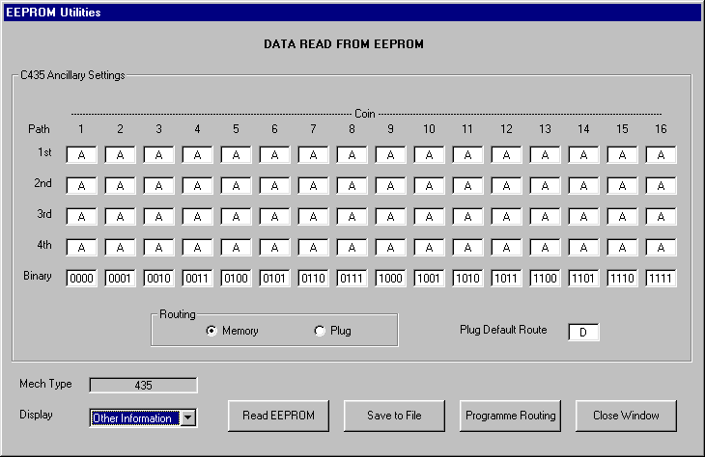
C435 BACTA
C435 Binary

- The C435 Ancillary Settings of Coin Routing and Binary Output code for each coin are shown. To change the settings manually overtype and then click on Programme Routing to programme the memory. This will use a credit.

Piezo sensor:
Due to problems experienced by our customers with the reliable working of the Piezo sensor (Parameter 5) it has been disabled in the generic Coinset Files. If this sensor is required for specific coins, please consult Mektek for a new Coinset File.

Coins accepted:
- Up to 16 coins can be accepted in binary output and up to 6 different value coins in parallel output. Note: In parallel output there are 2 banks of 6 coins but the outputs are paired. ie Channels 1 and 9 have the same output, 2 & 10 etc.
- Channels 5 & 13 are often set to a Token. To replace a Token with a coin during programming set the Rotary Switch to F to start and return it to C after programming.
Coin Inhibit:
- Coins are usually inhibited by the host machine via the interface connector and Bank Select switch on the mechanism.

Acceptance faults when fitted to host machines or validator test:

- In Binary mode check that both of the switches on the dual DiL bank on the rear of the mech are set to OFF
- If some types of coin are rejected check and remove any overlapping limits.
- If all coins are rejected it is likely that an unsuitable Coinset File has been used. Reprogram using a Coinset File that changes the binary coding etc to the standard required.
- Any overlapping limits or limit greater than 254 will cause coins to be rejected.
- If problems persist, use the Cloning Routine described in a previous chapter.

C450

Programme as basic Coin Controls routine but note the following:
- Looms required:
E20 C450 from socket 5 to validator
E23 C450 from socket 2 to validator
- Any overlapping limits or limit greater than 254 will cause coins to be rejected.

Routing:
- The coin routing is usually set to BDTA standard but it may have been changed. See below to check.
- 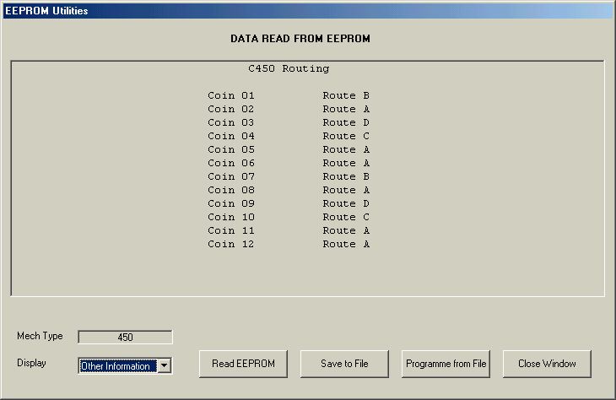Generally it is advisable to a Coinset File which leaves the routing unchanged. See the Coinset File Description section..
Display of other information:
- Read EEPROM and from Display select Other Information.
The routing for each coin is displayed.

Function of the banks of switches on rear of mechanism;
Switch Bank A:
- Coin Inhibits
Individual coins in six coin mode or pairs of coins in 12 coin mode can be inhibited using the 6-way switch.
Switch 1 UP to inhibit Coin Channels 1 & 7, switch 2 UP to inhibit Coin Channels 2 & 8 etc.
Switch Bank C:
- Coin mode:
Switch 4 DOWN selects six coin output and UP selects 12 coin binary output.
- Bank select:
Up to 12 coins can be accepted in two banks of 6 coins
Switch 5 DOWN enables coins 1 to 6.
Switch 6 DOWN enables coins 7 to 12.

Validator Test: Similar to C335 above but Binary display is not available.

Acceptance faults when fitted to host machines or validator test:
- If some types of coin are rejected check and remove any overlapping limits.
- If coins exit from the wrong router path it is likely that an unsuitable Coinset File has been used. Reprogram using a Coinset File that changes the routing to the standard required.
- If problems persist, use the Cloning Routine described in a previous section.

C220 & Sentinel:

See Appendix for listing of individual mechs supported.
Programme as basic Coin Controls routine but note the following:
- Binary Operation is not supported
Looms required;
E17 C220/Sentinel from socket 3 to validator
E25 C220/Sentinel from socket 2 to validator
Coin accepted:
- In normal mode coins 1 to 4 are output on pins 1 to 4 and coins 5 to 8 (If enabled) are also output on 1 to 4.

Coin Inhibit:
- Coins are usually inhibited by the host machine via the interface connector.

Acceptance faults when fitted to host machines:
- Reprogram using larger windows.
- Any overlapping limits or limit greater than 254 will cause coins to be rejected.
- If problems still occur, use the Cloning Routine described in a previous section.

NRI:

G13 family: See Appendix for listing of individual mechs supported.

Programme as basic NRI/Coin Controls routine but note the following:

CAUTION: Different Programmer connections are used for Acceptors and Totalisers. Connecting the E10 Ribbon Cable from an Acceptor to the G13 Tote socket on the Programmer can damage the Programmer and/or mechanism.
- Coinset Files with individual coin values are required for Totaliser variants. Consult Mektek for a Coinset File specific to your needs. Validator Test is not available for Totaliser variants.
- Looms required:
E10 G13/C120 (Ribbon) from socket 1 to validator as shown
E14 G13 from socket 2 to validator as shown.

Mechanism type identification:
Acceptors:
Type G13-0000 – one loom connection visible though back cover.
Type G13-6000 – both loom connections visible through back cover.
G13-1000 is a front plate version of G13-0000
G13-7000 is a front plate version of G13-6000
Totalisers:
A “2”, “3” or “4” in the red position indicates a Totaliser variant.
G13-0000

G13-60000

Measuring Parameters:
- The G13-6000 variants have selectable measuring parameters which are defined in the Coinset File.

Output & Inhibit Mapping: (G13-6000 series only)
- The ouput & inhibit mapping – which Channel is output on which pin and which Channel is inhibited by which switch – can be changed by use of a suitable Coinset File.
- If no coins are accepted on Validator Test after programming or when fitted to the host machine it is likely that an unsuitable Coinset File has been used.

Multiple output pulses on one output line:
- Multi-pulsing – eg one pulse for 50cent & 2 pulses for 1Euro – is defined in the Coinset File

Coins accepted:
- Up to 12 coins can be accepted in the G13-6000 family and up to 6 coins in the G13-0000 family

Coin Inhibit:
Individual coins can be inhibited using the 6-way switch(s) on the PCB.
- G13-0000 has switch bank. Switch 1 UP to inhibit Channel 1, switch 2 UP to inhibit Channel 2 etc.
- G13-6000 has 2 banks of switches. On Bank 1, Switch 1 UP to inhibit Channel 1, switch 2 UP to inhibit Channel 2 etc. On Bank 2, Switch 1 UP to inhibit Channel 7, switch 2 UP to inhibit Channel 8 etc.
- Totaliser: Refer to NRI Data Sheets.

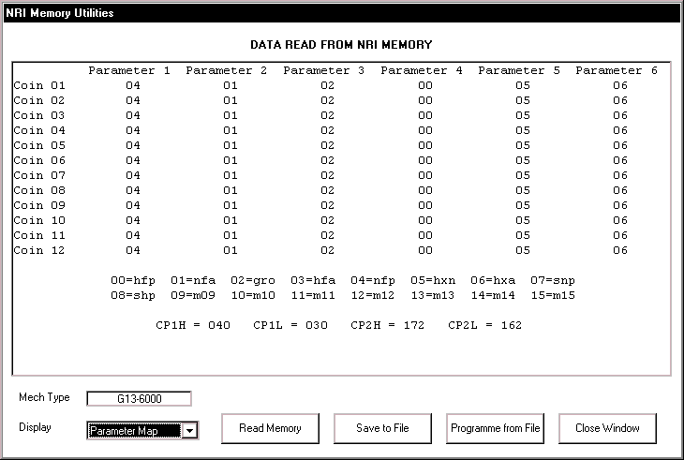
Display of other information:
- Read EEPROM and from Display select Parameter Map
The parameters used for each coin are displayed. The parameters used are defined in the Coinset File and cannot be altered during programming.

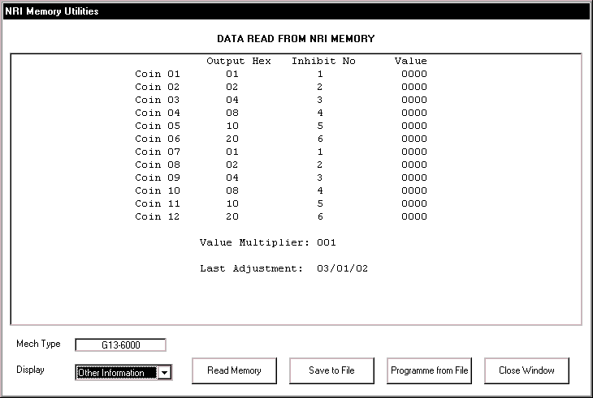
- From Display select Other Information
The output mapping and inhibit mapping for each coin are displayed.
The “Values” column refers to Totalisers only. These are defined in the Coinset File and cannot be altered during programming.

G10 family: See Appendix for listing of individual mechs supported.

Programme as basic NRI/Coin Controls routine but note the following:

- The Coinset File to be used will contain coin values, tube routing etc and therefore no generic coinsets are available. Consult Mektek for a Coinset File specific to your needs.
- Loom E15 G10 fitted from socket 4 to validator

Mechanism variants:
- There are various variants of the G10. Most of these are similar to the 4000 or 4000/5 and are supported by the programmer. If in doubt select NRI and Mech Type in the Main Menu and then EEPROM Utilities. If the correct type is selected the contents of the Memory will be displayed.
- Should you have an unsupported variant, contact Mektek to see if it can be added.
- Validator Test – is only supported on some of the variants.

G40 family: See appendix for listing of individual mechs supported. Check the loom cross-reference as there are two main types which have different connections.
Program as basic NRI routine but note the following:
- Coinset files with individual coin values are required. Consult Mektek for a Coinset file specific to your needs.
- Additional looms used – may require removal of rear cover
E13 (socket 3) & E26 (socket 2) for G40-x3xx & G40-x4xx
E14 (socket 2) & E20 (socket 5) for G40-x0xx, G40-x5xx & G40-x6xx
- Select the exact variant on Validator Test screen
Mechanism variant identification:
- The second digit in the model number denotes the main variant.
eg G40-x4xx There could be a variety of numbers in the “x” positions dependent on coin entry exit etc. but it is programmed as a G40-x4xx.
Measuring Parameters:
- Selectable measuring parameters are defined in the Coinset file.
Output mapping, inhibit mapping and sorter settings:
- The output and inhibit mapping – which channel is assigned to each of the 6 output lines and which channel is inhibited by which switch – along with the coin routings if a sorter is fitted are set by the Coinset file.
Multiple output pulses on one output line:
- Multi-pulsing – eg one pulse for 50cent & 2 pulses for 1Euro – is supported by the mechanism and is defined in the Coinset File
Coins accepted:
- Up to 12 coins can be accepted but there are 6 output lines.
Coin inhibit:
Individual coin channels can be inhibited using the two switches on the PCB.
- On the upper bank, Switch 1 ON to inhibit Channel 1, Switch 2 ON to inhibit Channel 2 etc.
- On the lower bank, switch 1 ON to inhibit Channel 7, Switch 2 ON to inhibit Channel 8 etc.
Validator Test:
- Before passing coins through the mech select the appropriate variant from the drop-down box on Validator Test screen.
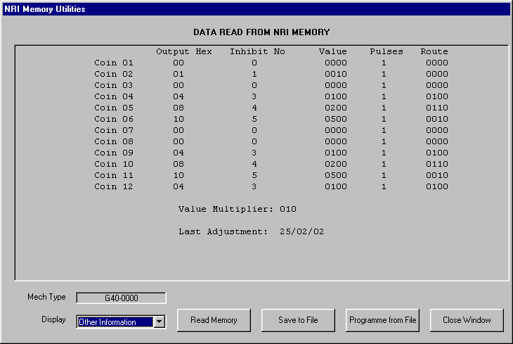
- Some mechanism variants support Binary Output and this can be selected from the Validator Test screen. See Coin Controls C335 section for details.
Display of other information:
- Read Memory and from Display select Parameter Map. The parameters used for each coin channel are displayed. The parameters used are defined in the Coinset File and cannot be altered during programming.
- From Display select Other Information. The output mapping in Hex, inhibit mapping, coin value, pulses and sorter routing is displayed for each coin. These values are defined in the Coinset File and cannot be altered during programming.

Help

Obtaining Coinset Files:
Generic coinset files covering most applications are included in the installation CD and can be downloaded from the Coinset Download page on our website www.mektekinternational.com.
Specific Coinset files for a particular application will be provided free-of-charge on request. Please discuss your requirement in detail with your Programmer supplier or Mektek UK Ltd.
Updated operating software:
New features, improvements and support of new types of coin mechanism are regularly being added to the Programmer operating system in response to user feedback. Check our website www.mektekinternational.com regularly and download the latest updates free-of-charge.
Technical Help & Fault Reporting
If you require help or advice relating to the operation of Mektek equipment:
- Check out the Programming Help page on our website www.mektekinternational.com
- Contact your local Mektek Programmer supplier directly or Mektek UK Ltd.
Check out the technical data available on the manufacturers’ websites.
- Mars – www.meiglobal.com
- NRI - www.nri.de
- Money Controls (Coin Controls) – www.moneycontrols.com

A good source of Manuals to download is www.norpay.de

Tables:
E+1 Switch settings

1 2
Switch 1 | When used as 1k select the active coin set |  | When used as 2k select the active coin segment via the validator links/switches
Switch 1 | ON | OFF | OFF | ON
Switch 1 | Seg 1 active | Seg 2 active | Not to be used | Normal setting

Switch 2 | When used as 1k or 2k enables erasing and programming
Switch 2 | ON | OFF
Switch 2 | Erase and program enabled  WARNING: Data will be erased if Switch 2 left ON when verified or fitted to a validator | E+1 is Read-only and cannot be altered

Fault-finding:
Description | Cause/Action
No response from programmer box | Comms fault - switch box off/on  Disconnect mech then if OK = faulty mech  Reboot system  Check PC to box loom  Check correct COMs port selected.
No validator detected | Check box to mech loom & correct looms fitted  Comms fault - switch box off/on  Faulty validator – check using Memory/EEPROM utilities if Coin Controls/NRI.
Coins not recognised when dropped during programming | Wrong coinset file used  Wrong looms used or looms not fitted  Mechanism not supported by Operating software version used – download latest software from our website.
Data device fails verify | PROM - check orientation in socket. Notch adjacent to red spot and opposite end to lever  PROM – remove and reseat in ZIF socket  E+1 – reset switch settings and retry.
Mech fails validator test  See additional routine below. | Mars: Check PROM/E+1 inserted correctly  Check switch settings on E+1  Single coin set - check Duplicate Segments used.  Mech incorrectly fitted to stand when programmed or tested - reprogram and retest.  Coin Controls/NRI: Check all looms fitted as specified.  Incorrect Coinset File used when programmed - confirm mech type, reprogram and retest.  Check and remove overlapping limits on C435/C435A  Maximum limit value of 254 exceeded.
Mech passes validator test but rejects coins on host machine. | C435/C435A – coinset file used which changed mapping etc. to inappropriate standard. Reprogram using correct coinset file or use Cloning Routine.
Coin Controls/NRI unable to read memory | Check looms  Check correct mech type selected  Faulty mechanism  Mechanism type not supported

Mechanism fails validator test after programming:

If a new type of mechanism is being programmed or different coins are being used and the mechanism fails validator test, first check the items in the table above. If this does not cure the problem carry out the following routine to identify and resolve the problem. (For future reference: If programming an NRI/CC mechanism, if possible use another mechanism of the same type that has not been reprogrammed and go to Read EEPROM and then Save to File to store the original values. If using a Mars keep the original PROM)

Identify the problem:
- Program the mechanism for one coin only in Channel 1 using a suitable Generic Coinset File and basic programming routine.
- Validator test and confirm that the coin is rejected.
- Go to the Wizards and run Edit Limits.
- There should be limits in Channel 1 only. Make a note of the limits generated. Overtype the generated limits for Parameter 3 with the values 1 and 240.
- Click on Change Limits
- Program a PROM/E+1 and fit to mech if Mars or program the EEEPROM if CC/NRI
- Run validator test. If the coin is accepted this is the Parameter which needs adjusting. Go to the Tuning Limits section below.
- If the coin is still not accepted repeat Steps 3,4,5,6&7 for each other Parameter in turn until coins are accepted. Now go to Edit Limits and overtype with the original limits except for the parameter which caused coins to be accepted. Repeat Steps 5,6&7. (If coins are not now accepted one of the other Parameters needs to have its window width increased.) We have now identified which Parameter(s) need to be adjusted. Go to the Tuning Limits section below.
- If the coin is not accepted after all Parameters have been changed to 1 - 240 then contact Mektek UK for assistance.

Tuning Limits: (For CC/NRI mechs reprogram the EEPROM. For Mars mechs use an E+1 or new PROMs).
- Go back and run the Edit Limits Wizard.
- Overtype all parameters with the original values. From now on we will only adjust the parameter(s) which were identified in the previous section.
- Decrease the lower limit and increase the upper limit by increments until the coin is accepted.
- Make a note of how much the lower limit(s) was reduced and how the upper limit(s) was increased.
- Apply this adjustment manually when programming this type of mechanism/coin combination or contact Mektek UK for a free-of-charge Coinset File which makes the adjustment automatically.
Description of Capture Measurements Screen
NOTES:
Coin Channel: Coin A1 goes into the first channel A of segment 1 in the E+1. Coin B1 goes into the second channel B of segment 1 etc. Coin A2 would be the A coin in segment 2.

Number of Coins Remaining: Will decrease to zero as coins requested are dropped through the validator.

Mech Type: The family of mechs suitable for use with this Coinset File.

For each parameter eg Thickness, the sensor readings from the mech and the calculated measurements from the Programmer are displayed and updated as each coin is dropped.
Measurement – the sensor reading of the actual coin dropped.
Mean – the mean values for coins dropped so far
SD – Standard Deviation of the coins dropped so far
Lowest/highest – values for the coins dropped so far.
Limit Source – number of SDs each side of the mean
Offset – adjustments to Limit Source
PROM Limits – calculated limits for coins dropped so far.

Duplicate Segments: (Mars only) Puts the same data in both segments of the PROM

Log Results: Ticking this box before dropping coins will open a dialog box to create a new Xcel file that records all the measurement readings in detail on a spreadsheet.

PROM Size: (Mars only) Selects the PROM size to be used (Tick 2k only if a 2k PROM and all 4 segments are to be used)

PROM Segments: (Mars only) Tick segments to be used (Not required if Duplicate Segments is ticked)

Description of PROM Limits Screen
DESCRIPTION OF GENERIC COINSET FILES
NOTE:
Special Coinset Files are available on request free-of-charge from Mektek UK Ltd. For example, Coinset Files can be provided that automatically copy existing data from one segment to another, identify by name the coins to be dropped, alter the output routing, widen specific window limits, etc.
For Coin A1 the Limits generated for each parameter are shown along with the Estimated Acceptance %age (based on the coins used for programming)

In this case a possible Slug has also been dropped through and
the Estimated Rejection &age shown. If these two sections were highlighted it would mean the Slug would be accepted and the Limits of the Coin A need to be adjusted.

Display PROM Segment (Mars only): Tick on this sevction to display the contents of the other Segments.
Mars
MS1000 family:
MS1000 coinset files work on most of the MS1000 family including MS1600, MS1604, MS1610, MS1614, MS1900, MS1904, MS1910, ME1099, ME1100,
MS1000A add up to 6 new coins to segment 1
MS1000B add up to 12 new coins
ME111 family:
ME111 coinset files work on most of the MS100 family including ME111, ME115, ME115TS, MS111B1, MS111, ME126, ME129, & MS130B1, MS15, MS16, MS25, MS10, MS12 (For the MS150 consult Mektek).
Special Coinset Files which include coin values are required for the ME112 and ME181 – contact Mektek.
Mech variants: If loom E2 or E8 fits the lower left-hand connector on the coin mechanism then use ME111 Coinset Files.
ME111A add up to 6 new coins to segment 1
ME111B add up to 12 new coins
NRI
G13 Family: Acceptor only – for Totaliser variants contact Mektek UK Ltd
The G13 0000 and G13 6000 series require different Coinset Files.
G13-6000A add up to 6 new coins 1-6, outputs/inhibits 1-6 respectively
G13-6000B add up to 12 new coins, outputs/inhibits 1-6 & 1-6 respectively
G13-0000A add up to 6 new coins to channels 1-6
G18: Acceptor only – for Totaliser variants contact Mektek UIK Ltd.
G18-3000A add up to 6 new coins (Output/inhibit 1-6)
G18-3000B add up to 12 new coins (output/inhibit 1-6 & 1-6)
G10: These coinsets contain individual coin values for each channel and change tube routing. Coinsets for this mechanism are available from Mektek UK Ltd. on request free-of-charge..
G10-4000Euro adds coins 5c/10c/20c/50c/1euro/2euro to channels 1-6 & 5c/10c/50c to coin tubes left/middle/right
Coin Controls
C220B:
C220BA add up to 4 new coins to channels 1-4 – output on pins 2,4,5,7
C220BB add up to 8 new coins1-8 – output on pins 2,4,5,7 and 2,4,5,7
C335:
C335A add up to 5 new coins to channels 1-5 output on pins 3,5,6,8,1
C335B add up to 8 new coins. Output on pins 3,5,6,8,1 (Coins 6,7,& 8 twinned with coins 1,2 & 3 respectively)
C435 family:
The routing of coins through the in-built sorter in the mechanism can be defined in the memory of the mech or via an external header routing plug. Generic Coinset files use the routing plug with default route "A". The Piezo sensor is disabled in the Generic Coinset files for all coins. The Coinset files below do not change the binary coding or output routing. If changes to these are required either contact Mektek UK Ltd for specific Coinset files for your application or change them manually during programming.
C435 & C435A:
C435 8 coins - add up to 8 new coins (Binary Coding and Routing unchanged, Piezo disabled)
C435 16 coins - add up to 16 coins (Binary Coding and Routing unchanged, Piezo disabled)
C450 family:
C450A add up to 6 new coins (Routing unchanged)
C450B add up to 12 new coins (Routing unchanged)
C120 family:
The C120, C122 and C123 use the C120 Coinset Files.
C120 All 12 coins New & Jaguar type - add up to up to 12 new coins (Mapping unchanged)
C120New A New type mech - add up to 12 new coins (Mapped 1-6 & 1-6)
C120JaguarA Jaguar type mech - add up to 12 new coins (Mapped 1-6 & 1-6)
C220, C220A, Sentinel:
SentinelA add up to 4 new coins (Routing unchanged)
SentinelB add up to 8 new coins (Routing unchanged)

Plus Program

Basic programming routine (CF115/126, 560)
- Clean and dry the path of the coins through the validator using a soft cloth and a foaming non-solvent cleaner.
- Connect the validator to programmer using appropriate loom (Refer to “Connecting loom selection” in the Help section at the end of the Manual)
- Mount the validator in the stand in the correct alignment. (For the CF560 remove the validator from the changegiver channel.)
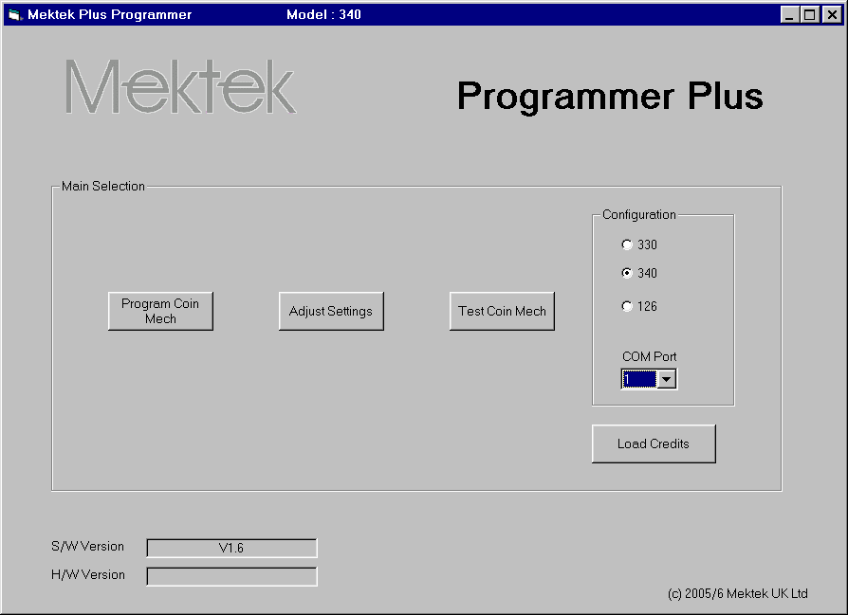
- Start the Programmer system from Start, Programs, Mektek, Programmer Plus and the Main Selection menu will appear.
- Select the correct type of mechanism click on Test Coin Mech.
- Drop current coins through the mech and check acceptance to confirm that the validator is working.
- Return to the main selection. Click on Programme Coin Mech
- The screen goes grey and there is a pause while the coin mech EEPROM (memory) is read – blue bars at bottom of screen show progress.
Once the EEPROM has been read the Programme Coin screen appears and the Serial number of the unit is displayed.
NOTE:
If a coin is being inhibited by the validator it will not show as accepted on the screen. Check the validator LED to confirm. See Appendix for details of LED codes.

- The first time a particular discriminator is read a Backup file of the original data is automatically created. This can be used to restore the original configuration. See Appendix for details.

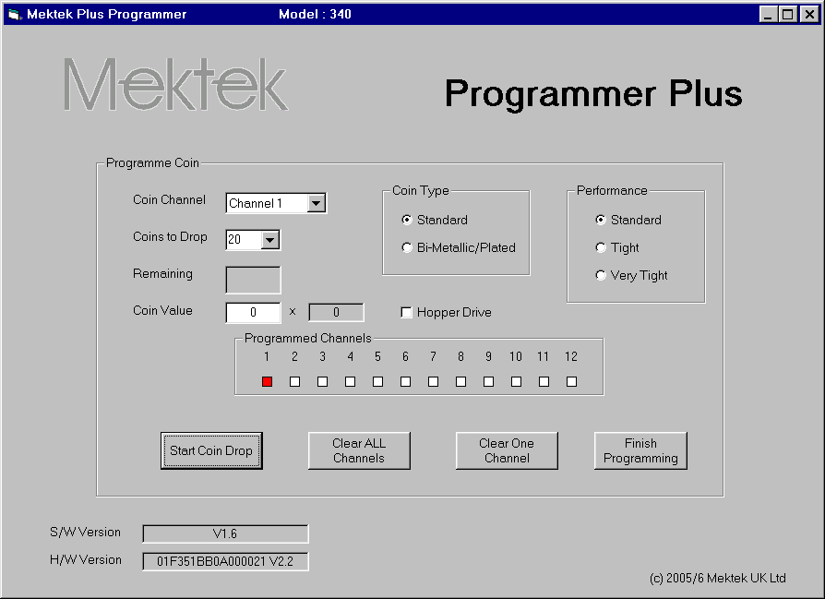
NOTE:
The square 6way connector on one branch of the X3 and X4 looms that plugs into the front of the mechanism can become insecure during programming leading to a lack of communication with the programmer. Always ensure that the connector remains fully home and in the horizontal position.

NOTES:
Coin channel – using the Drop Down select the coin channel to be programmed (from 1 to 16 for a CF126)
Coins to drop –20 coins is recommended.
Coin type – select either standard or Bi-metallic/plated dependent on the material of the coins.
Performance – the Coin Limits can be made tighter to reduce the chance of false coins, or slugs, being accepted. This will also mean that some genuine coins may not be accepted.
Programmed Channels – where a Channel is coloured RED a coin has already been programmed into that channel.
Clear ALL Channels – all Coin Channels currently programmed will be cleared.
Clear ONE channel – the Coin Channel currently selected will be cleared.

- If the coin mechanism is to be completely reprogrammed – clear all Coin Channels by clicking on Clear ALL Channels. Click on OK when this message appears.

- If selected Channels only are to be programmed, select the first one in Coin Channel, then click on Clear ONE Channel.
A similar message will appear. Click on OK to proceed. Repeat for any other Channels to be cleared.

- Click on Start Coin Drop.
The quantity of Coins to Drop appears in the Remaining window.
- Drop coins through the mechanism – as each coin passes through the Remaining quantity reduces.
- When all coins have been dropped the Remaining value will be zero and the message Data Gathered appears.
- Click on OK to return to the Coin Programme screen.

The Coin Channel will have stepped on to the next Channel automatically.

- To programme more coins repeat the Coin Drop procedure for each type
of coin required.
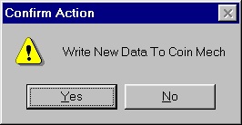

- When all the required coins have been programmed click on Finish Programming.
- Click on OK to write the new data to the coin mech EEPROM.
- The Deduct Credits message appears. At this stage a Credit will be deducted from the total held in the Programmer. Click on OK to proceed.

- The screen goes grey and there is a pause while the programmer writes the new data to the coin mech EEPROM (memory) – blue bars at bottom of screen show progress.
- This is followed by a similar process to verify that the data has been correctly written .
- When completed click on OK to complete.
- The screen now reverts to Main Selection.
- Click on Test Coin Mech to verify the performance of the newly programmed coins and the Test Coin Mech screen appears. Note: The example shown is for the CF126 & 330 series – for CF340 see the relevant chapter.
- Select the type of ouput to be used – Parallel or BCO (binary) using the Binary mode tick box. See box below for Lamp Sequences in Binary Mode. For an explanation of output modes see the next chapter on “Settings.
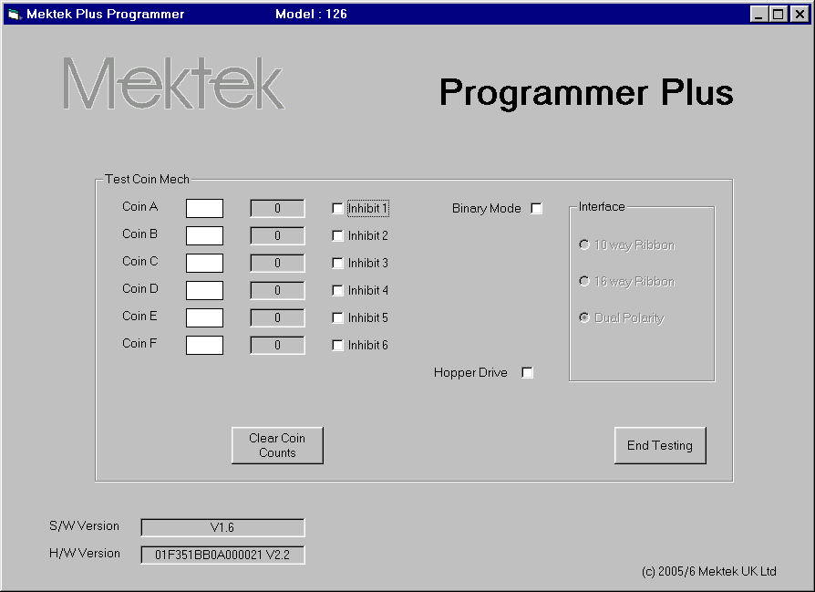

- Drop a coin through the mechanism. If it is accepted the appropriate Coin box will light up green. Allow time for the light to extinguish before dropping the next coin.

- To test the inhibit line for the channel, tick the Inhibit box and drop a coin. The green light should not light but the green LED on the validator should flash 3 times to verify the inhibit line is OK. This does not mean that the channel will be inhibited after programming.
- Repeat for all coins to verify the performance of the programming.
- If known false coins (slugs) are available drop these through the mech to verify that they are rejected.
- Click on End Testing to return to the Main Selection menu.
NOTE : If a coin is inhibited it will not show as accepted on the screen but the validator LED will flash off four times.
NOTE: If false coins are being accepted on one channel, the Coin Limits for this coin can be tightened by going back to the Main Selection menu, then Programme Coin Mech. Tick the Tight box in the Performance section and then repeat the programming & test routines for the Channel. No additional Credit is deducted for this action.

Testing in Binary Mode:
Output Number Lamp F Lamp E Lamp D Lamp B BCode value(Hex) UK BACTA coin (Example)
0 Off Off Off Off 00 5p
1 On Off Off Off 01
2 Off On Off Off 02
3 On On Off Off 03 20p
4 Off Off On Off 04
5 On Off On Off 05 50p new
6 Off On On Off 06 Token
7 On On On Off 07
8 Off Off Off On 08
9 On Off Off On 09 50p old (sometimes token)
10 Off On Off On 0A £1
11 On On Off On 0B
12 Off Off On On 0C 10p
13 On Off On On 0D
14 Off On On On 0E
15 On On On On 0F £2
Lamp C should flash for every coin.
Any Programmed Channel can have any BCode value.

Settings (CF560)
With the Mektek Plus system you can program and test new coins in any channel of the CF560. However, there are some things that may need to be set in the changegiver itself afterwards using an MEI Route Alpha unit. (For full details and instructions refer to a Route Alpha Operator’s Guide)
For instance:
- Individual coin inhibits – addresses 229,230 & 231Coin routings (To cashbox or a tube) – addresses 291-294 for 1st channel to a tube & 301-304 for 2nd channel to a tube.
- Coin value – addresses 321-332.
- Remove the validator with the sorter from the channel before programming.
- Use loom X3 or X4 and connect the square black connector ONLY.

Settings (CF115, 126 & 330)

Depending on the type of mechanism being programmed some or all of the settings below can be adjusted for each coin channel. Further information on all the settings can be found in the relevant manufacturer’s Design Guide and User Guide.
- Enable channel
- Window width
- Output line
- BCO Hex Code
- BCO inhibit line
Note: Items 6 & 7 are available only in the CF115/126
- Routing header
- Memory routing

Changing settings – standard routine

- Click on Adjust Settings in the Main selection menu.
- The screen goes grey and there is a pause while the coin mech EEPROM (memory) is read – blue bars at bottom of screen show progress. Once the EEPROM has been read the Adjust Mech Settings screen appears.
- Make all the required changes to the Coin Channels as described below.
- Click on Write to Mech to save the changes.
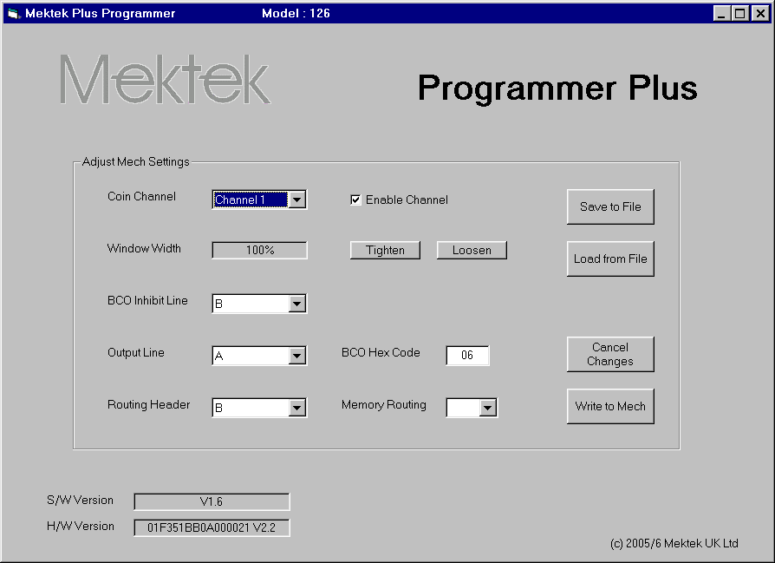
Description of settings:
In each case select the Coin Channel to be set from the Coin channel drop-down menu

- Enable the channel: coins will be accepted in this channel.
- Tick the Enable Channel box to allow coins to be accepted.

- Window width: increases or deceases the discrimination of the channel.
- Click on Tighten to decrease the width of the coin limit window in 2% increments.
- Click on Loosen to increase the window width in 2% increments.

- Output Line: (Parallel output) Used when the mech is to be fitted to a host machine that requires a parallel output from the machine interface connector. In parallel output mode, when a valid coin has been accepted by the validator a signal is sent down the Coin Output line associated with that coin’s channel to the host machine. Each of the 16 Coin Channels is associated with one of the 6 Coin Output lines.
Eg Coin Channels 9 & 10 could be programmed to the same £1 coin but with Channel 10 set to tight Window Width for use in high risk areas. Both of the Coin Channels would then be associated with the same Coin Output line.
NOTE: In the standard GB coinset mech there is the additional option of MPE in the Output Line drop-down menu. This will pulse the GB 50p coin output line four times on validation of a GB £2 coin.

To assign a Coin Channel to a particular Coin Output line;
- Select the required Coin Channel
- Click on the Output Line drop-down menu
- Click on the required Output line – A to F
NOTE: Inhibit lines - in parallel output mode the inhibit lines are fixed to the coin output lines.
e.g. Inhibit Line A will inhibit the acceptance of all channels associated with Coin Output line A.

- BCO Hex Code: Used when the mech is to be fitted to a host machine that requires a Binary Coded Output (BCO) from the machine interface connector. In the BACTA Standard Definition BCO mode, when a valid coin has been accepted by the validator a binary code, dependent on the coin accepted, is sent down Coin Output lines F,E,D,B&C to the host machine. Each of the 16 Coin Channels can have a separate binary code if required. The required binary code for a coin channel can be set by inputting the corresponding Hex Code. See box on Page 33.
- Select the required Coin Channel
- Click on the BCO Hex code box.
- Input the required Hex code.
CAUTION: Incorrect setting of the BCO Hex Code will lead to problems when the mech is fitted to the host machine. Change these settings only if you are fully conversant with the process.

- BCO Inhibit Line: Used when the mech is to be fitted to a host machine that uses a Binary Coded Output (BCO) from the machine interface connector. There are 6 inhibit lines labelled A to F. Each of the 16 Coin Channels must be assigned to one of these inhibit lines.
- Select the required Coin Channel
- Click on the BCO Inhibit Line drop-down menu
- Click on the required inhibit line.

ROUTING: (Available in the CF126 only) A “Separator” may be fitted to the mech to route accepted coins from the validator to various exits from the router which correspond to hoppers on the host machine. The routing of the coins is be set in one of two ways:
Memory – the routing is written to the validator EEPROM.
Routing Plug – a 22-way connector is hard-wired with the required combinations and inserted into the validator (Insertion of a Routing Plug will override Memory settings.) For details of how to wire a Routing Plug consult the relevant manufacturer’s design guide.

- Routing header: (the header into which the routing plug is inserted) A routing plug can route up to 8 different coin types (A to H) into 4 or 8 different exits – depending on the type of router fitted. As the mech can accept up to 16 different coins each coin must be assigned to one of the coin types A – H in the routing header.
- Select the required Coin Channel
- Click on the Routing Header drop-down menu
- Click on the required coin line.

- Memory routing: If a Routing Plug is not inserted the routing can be set in the validator EEPROM.
- Select the required Coin Channel
- Click on the Memory Routing drop-down menu
- Click on the required exit.
Once all required changes have been made click on Write to Mech to save the information in the validator.

CF330 & CF340

Settings:
Same as CF126 above

Reprogramming
The routine for reprogramming is similar to that described for the CF126 in the previous chapter with the exception of the Discriminator Type selection detailed below.

Discriminator Type Selection: CF330 & CF340
Some older discriminator modules have different sensor scaling values. It is important that the correct type is selected to ensure successful programming.

When faced with a CF330 or CF340 discriminator of unknown type or a new coin go through the following sequence for programming:
Test with old coins to check that the mech is working in the first place

Programme new coins as "type 1" - in the case of a new coin issue it may be necessary on the first mech to establish whether the "Standard" or "bi-metallic/plated" option is required. Type 1 seems to cover the majority of coin mechs.

If Type 1 fails try as Type 2 on one coin. (Do not exit the software or try another coin mech so that no more credits are deducted). If this works programme the remaining coins as Type 2.

If Type 2 fails try as Type 3 on one coin. (Do not exit the software or try another coin mech so that no more credits are deducted). If this works programme the remaining coins as Type 3.

As a last resort clone the configuration of an identical mechanism with the required configuration.

CF340 Creditor - Extra features, reprogramming & settings

Interface board
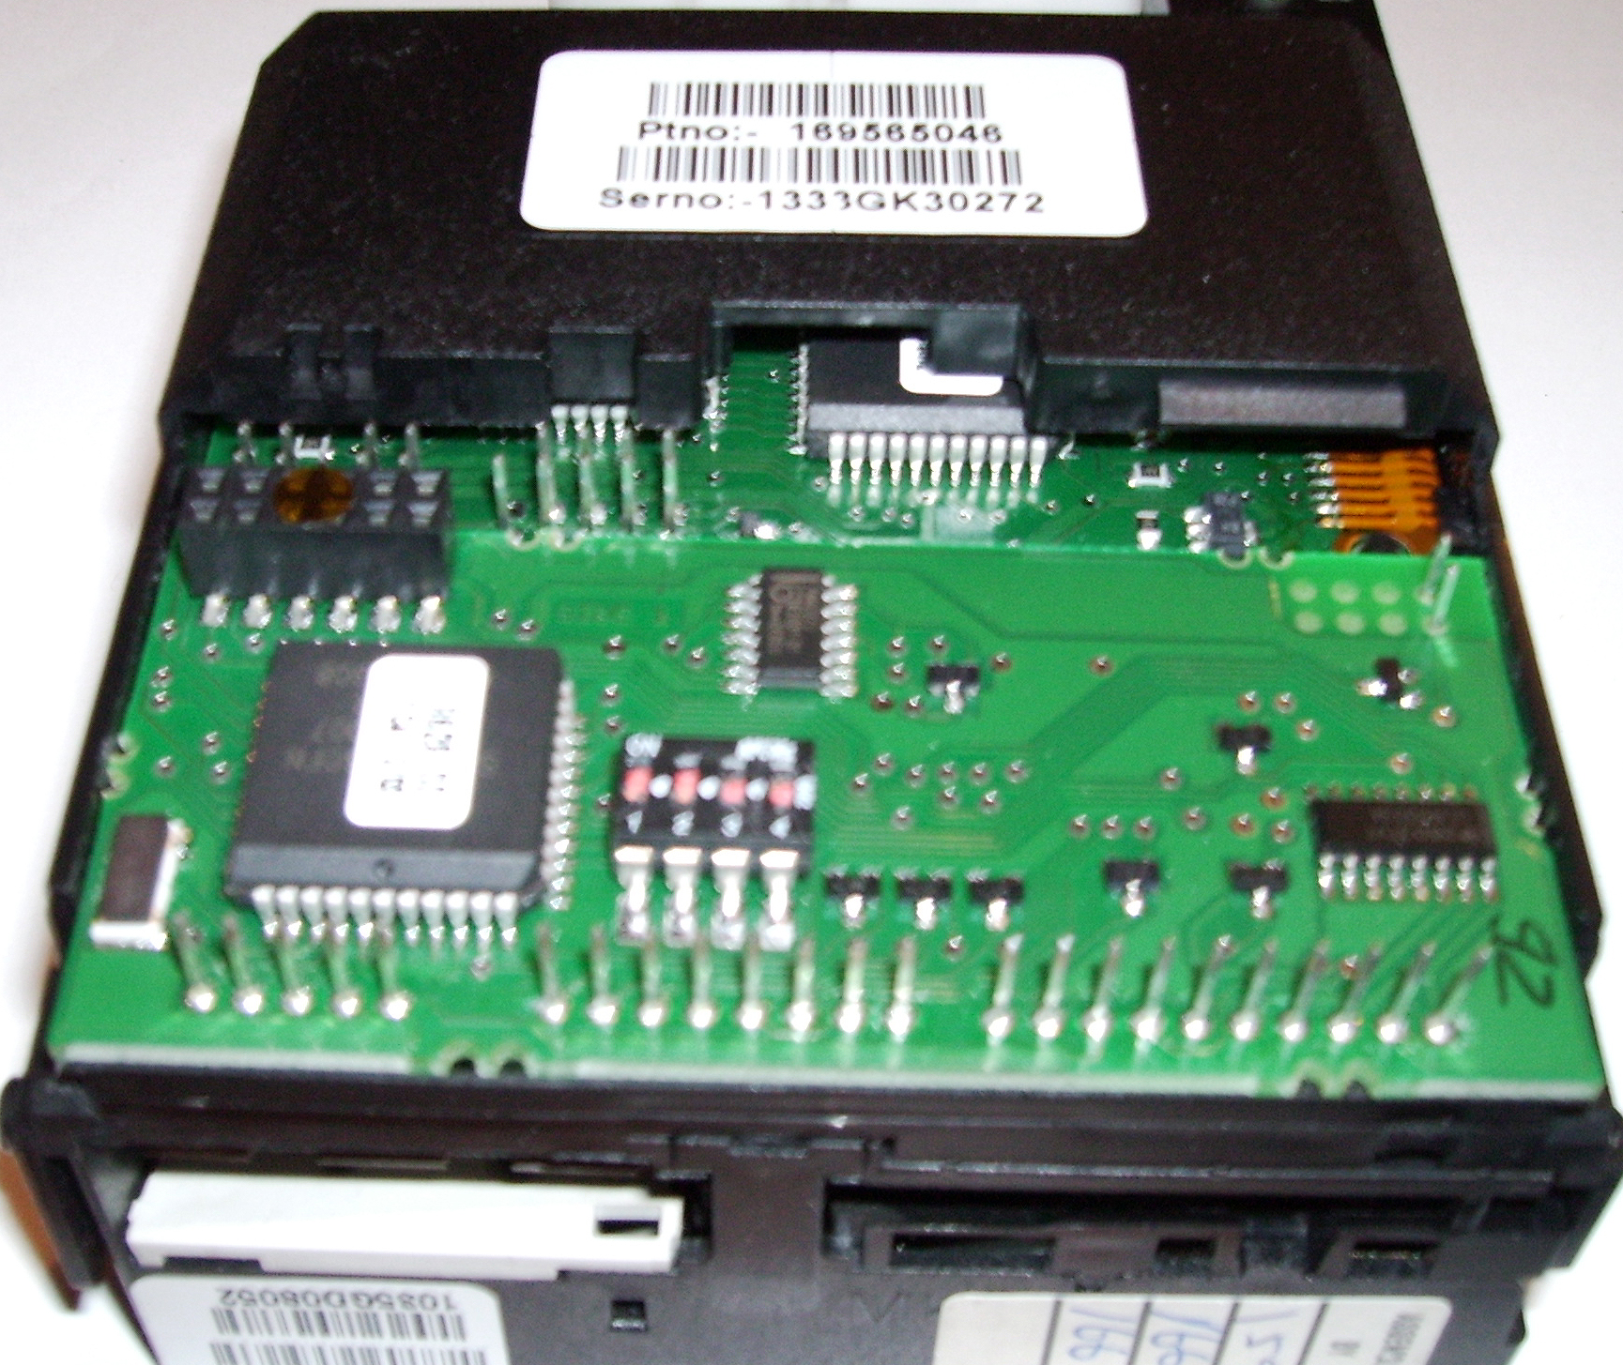
The CF340 is fitted with an RVCI (Robust Video Credit Interface) PCB attached directly to the rear of the acceptor underneath the plastic cover. There are two modes of the RVCI – single player and 4 player – with appropriate dispense inputs and outputs. Both provide a player lamp output (P Lamp), entry lamp output (E Lamp), a coin meter output and an auxiliary credit input.

RVCI Function
The RVCI performs credit accumulation and host interface functions. On receipt of a coin accepted signal from the acceptor, the unit assigns the appropriate value to the coin and adds this value to the accumulated credit. If the coin meter is enabled, the unit will send an appropriate number of pulses to the coin meter output.

Single & multi player forms
In the single player form, the unit can be configured for either automatic or manual credit dispense. In automatic credit dispense the appropriate number of game pulses will be dispensed when the accumulated credit exceeds the game price. In manual credit dispense a single game pulse will be sent to the appropriate player output each time the corresponding Player input becomes active and enough game credits are available.
In multi player form only manual credit dispense can be used.
In manual credit dispense mode, the creditor will drive the Player Lamp output to indicate that there are game credits available. The lamp(s) will flash when game credits exist.

Bonuses
The creditor can be configured to give additional games at two defined bonus credit levels. The number of additional games for each bonus level is programmable. The additional games will be given when the bonus credit level is reached within a programmable time limit. NOTE: Do not use Bonus 1

Reprogramming
The routine for reprogramming is similar to that described for the 126 with the exception of the Test Coin function below and the Discriminator Type selection detailed in the CF330 & CF340 section above.
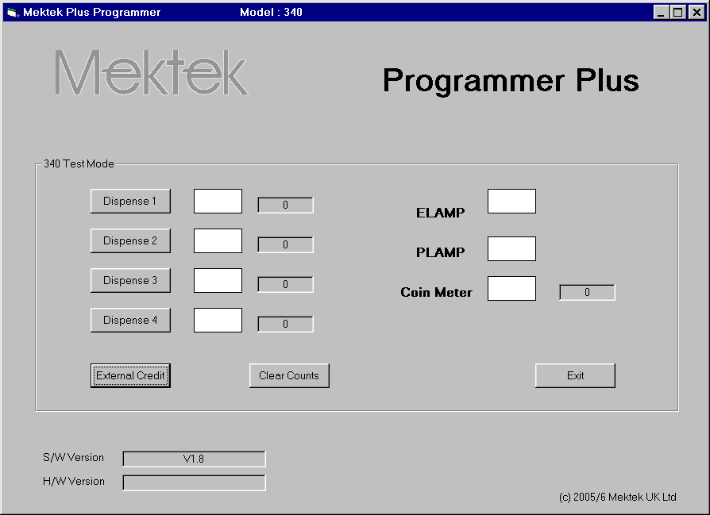
Test function
When a coin is inserted, the Elamp lights and stays on. The value of the coin is added to the accumulated credit. The Coin Meter lamp will flash and the Coin Meter counter will increase by the value of the coin divided by the coin ratio. Once the accumulated credit equals or exceeds the game price the Plamp will flash.
In Manual Dispense setting, each click on Dispense 1 will send a single game pulse to Player 1 and the number of game pulses sent will appear in the adjacent window. Similarly Dispense 2 will send a pulse to Player 2 etc.

Settings

Depending whether the mechanism being programmed is a 1 or 4 player type the settings described below can be read and, in most cases, adjusted. Further information on all the settings can be found in the relevant manufacturer’s Design Guide and User Guide.
By mechanism:
Scaling factor
Game price
1 or 4 player
Coin meter value
Coin meter enable
Manual or automatic dispense
By coin channel:
Enable Channel
Coin value
Window width
External credit value
Credit input enable
Alarm enable
Bonus enable
Bonus 1 level & Bonus 1 games
(Do not use Bonus 1)
Bonus 2 level & Bonus 2 games

Changing settings – standard routine

- Click on Adjust Settings in the Main selection menu.
- The screen goes grey and there is a pause while the coin mech EEPROM (memory) is read – blue bars at bottom of screen show progress.
Once the EEPROM has been read the Adjust Mech Settings screen appears.
- Make all the required changes as described below.
- Click on Write to Mech to save the changes.

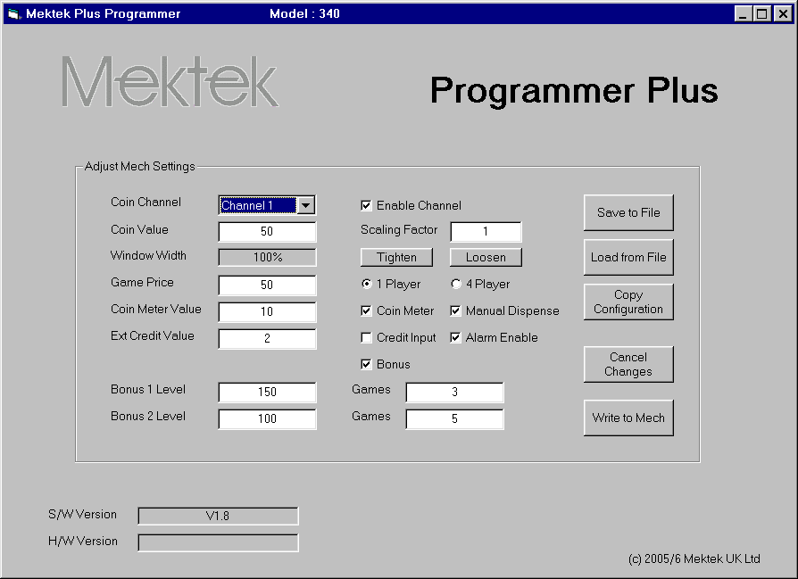

Description of settings:
For For the following settings first select the coin channel to be set from the Coin Channel drop-down menu.
- Enable the channel: coins will be accepted in this channel.
- Tick the Enable Channel box to allow coins to be accepted.
- Coin Value: the value of the coin.
- Enter the real value of the coin divided by the Scaling Factor.
- Window width: increases/deceases the discrimination of the channel.
- Click on Tighten to decrease the width of the coin limit window in 2% increments.
- Click on Loosen to increase the window width in 2% increments.
The remainder of the settings apply to the entire mechanism rather than to each coin.
- Scaling factor: Payment scaling factor applied to coin value
- Enter the required scaling factor.
- Game Price: the required credit for a game output.
- Enter the required value.
- 1Player/4 player : Select the mode of operation.
- Coin meter: Enables or disables the Coin Meter function.
- Tick the box for Enable or untick for Disable
- Coin meter value: Number of pulses = credit divided by this value.
- Enter required scalar value.
- Manual Dispense: Manual Dispense mode to be enabled. (Manual must be selected for 4 player mechs)
- Tick box to select Manual Dispense mode or untick for Automatic.
- Credit Input: Enables auxiliary credit input.
- Tick box to enable auxiliary credit input.
Ext credit value: Value of external (auxiliary) credit.
- Enter the value required divided by the Payment Scaling Factor.
- Alarm enable:
- Tick box to enable detection of coin stringing etc. (which will flash the ELAMP if detected).
- Bonus: Enables or disables the use of Bonus Games.
- Tick the box to enable bonus games.
- Bonus 1 Level & Games: Due to a temporary software issue Bonus 1 should not be used. Use Bonus 2.
- Bonus 2 Level: When accumulated credit reaches this level the number of bonus games in Bonus Games is awarded.
Enter the value of credit required to trigger Bonus 2 games
- Bonus 2 Games: When the value of credit set in Bonus 2 Level is reached this number of bonus games will be awarded.
- Enter the number of bonus games to be awarded at Level 2.

Utilities
1. Save to file: Saves the entire contents of the memory of the mechanism. With the mechanism connected to the programmer, Click on Adjust Settings, and then on Save to File once the Adjust Mech Settings screen appears. Enter a convenient name and folder and save. By saving the information a mechanism can be restored to this configuration if required. NOTE: The first time a particular serial number discriminator is read a backup copy of the original data is automatically saved. See Appendix for details.
2. Load from File: Replaces the entire contents of the memory of the mechanism with the information in a Saved File (See above).
With the mechanism connected to the programmer, Click on Adjust Settings, and then on Load from File once the Adjust Mech Settings screen appears. When the dialogue box appears, select the required saved file and then Open.
3. Copy Configuration: This special utility enables mechanisms that have corrupt memory or incorrect settings which result in the mechanism malfunctioning to be corrected by reference to a known working mechanism.
Connect a known working mechanism of the same configuration as the malfunctioning mechanism to the programmer. Click on Adjust Settings and then Save to File (See above). Remove the mechanism.
Connect the malfunctioning mechanism and click on Adjust Settings. Click on Copy Configuration and follow the instructions.
Note: Copy Configuration copies everything except the serial number, coin windows and coin reference data. (Note - it does change the coin enable/inhibits) After using the Copy Configuration utility it is vital to check that the correct coin channels are enabled and that the channels are correctly assigned to the expected output. It is also recommended that all the coins be reprogrammed.

Validator LED code (115/126 only)
A green LED is visible on the front of the validator once power has been applied. As a coin is passed through the validator the LED will flash a number of times depending on the status of the coin.
Flash off once: the coin is valid and has been accepted
Flash off twice: the coin is outside the programmed coin limits and is rejected
Flash off three times: the coin has been rejected by the fourth sensor
Flash off four times: the coin has been inhibited by hardware or software.

Backup File & Restoring Original Configuration
The first time a particular serial number discriminator is read a backup copy of the original data is automatically saved in the folder C:\ProgramFiles\Xprogrammer\Backup\. The file name is NNNNxxNNNNN.txt where NNNNNNNNNN matches the serial number on the discriminator label. (the bottom number on the angled barcode label on a 330 or 340 or on the LHS of a 126.) For example: for discriminator number 1913Y504930 the filename is 1913xx04930.txt (The Y5 is not readable through the HI2 connector). The Backup file can be used to restore a unit to its original configuration if required)

Help
Updated operating software:
New features, improvements and support of new types of coin mechanism are regularly being added to the Programmer operating system in response to user feedback. Check our website www.mektekinternational.com regularly and download the latest software updates free-of-charge.
Technical Help & Fault Reporting
If you require help or advice relating to the operation of Mektek equipment:
- Check out the Programming Tips pages on our website www.mektekinternational.com
- Contact your local Mektek Programmer supplier directly or Mektek Uk Ltd.
Check out the technical data available on these websites.
- NRI - www.nri.de
- Money Controls (Coin Controls) – www.moneycontrols.com
- Loads of Cashflow manuals for download - www.norpay.se/dl_acceptors.e.php

Fault-finding table
:
Description | Cause/Action
No response from programmer box | Incorrect COM port selected  Check PSU connected.  Comms fault - switch box off/on  Disconnect mech then if OK = faulty mech  Reboot system  Check PC to box loom  Operating system conflict for selected COM port
Failure to connect to coin mech | Check box to mech loom  Comms fault - switch box off/on
Coins not recognised when dropped during programming | Wrong looms used or looms not fitted  6-way square connector on loom not fully seated in the front of the validator.
Mech fails validator test | Coin inhibit applied – check the code of the LED flashes  Switch box off/on and retry  Mech incorrectly fitted to stand when programmed or tested – reprogram and retest.
Mech passes validator test but rejects coins on host machine. | Settings incorrect – check outputs if BCO used.

Connecting loom selection

Depending on the type of mechanism and the interface board fitted different looms may be required
The square 6way connector on one branch of the X3 and X4 looms that plugs into the front of the mechanism can become insecure during programming leading to a lack of communication with the programmer. Always ensure that the connector remains fully home and in the horizontal position.

CF115/126
Use loom X3 – connect both branches.
Do not connect here – it will damage the mechanism

CF330
The CF330 series may have one of six different standard interfaces fitted. Check the connectors on the interface at the bottom of the validator to help determine which one to use. Refer to the MEI Cashflow 330 Product Maintenance Handbook for full information.
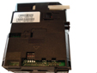
Interface
Interface 112 16 pin connector in 2 rows Loom E20 & X3
(Use X3 6way connector branch only)
Interface 124 Refer to Mektek
Interface 212 10 way ribbon connector Loom E10 & X3
(Use X3 6way connector branch only)
Interface 312 Refer to Mektek
Dual polarity 17 pin connector in 1 row Loom X3 only

Version 112 pin layout
Dual polarity pin layout
Version 212 pin layout

CF340
Use loom X4 – connect both branches. The 6-way square connector fits into the front of the mechanism and the 19 way connector fits onto the RVCI interface board on the rear.

CF560
Remove validator from changegiver channel. Use loom X3 or X4 – connect only the 6-way square connector into the front of the validator.

Coin mech type | Loom number
MEI CF126 series  CF115 is a CF126 without separator | X3 (17 pin connector in 1 row & 6way square connector).
MEI CF330 series | E10(10 way ribbon) or E20(16 way ribbon) and X3(6 pin square connector) See above
MEI CF340 | X4 (19 pin connector in 1 row & 6way square connector)
MEI CF560 | X3 or X4 (Connect 6-pin square connector ONLY)

